**“Laundry Expert”**

**Laundry E-Business Website**

Test case

1. Login (customer)

Scenario:

* Username and password are empty;
* Username does not exist in the database;
* Password is wrong;

Outcome: Error window“username or password error”.

1. Login (manager and deliveryman)

Scenario: Username and password are correct;

Outcome: Jump to manager or deliveryman interface.

1. Register (blank)

Scenario: Leave one or all fields blank;

Outcome: Error messages are filled in the field: the username cannot be empty; the password cannot be empty; the phone number cannot be empty; the email address cannot be empty.

1. Register (format error)

Scenario: Entry is not in line with the format of the mailbox;

Outcome: Error messages are filled in the field: email address format is wrong.

1. Make Order (not login)

Scenario: Click ‘make order’ button before login;

Outcome: Jump to login page.

1. Make Order (same clothing)

Scenario: Click same clothing for 5 times;

Outcome: Add 5 this clothing into shopping cart with total price.

Design diagram

1. Architecture diagram

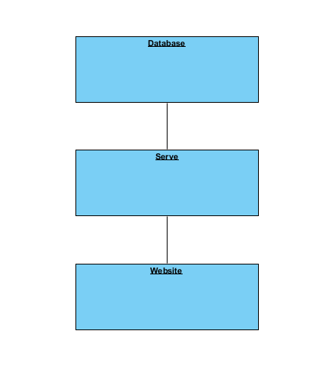

1. Database schema
2. Table: Customer

|  |  |  |
| --- | --- | --- |
| **Name** | **Type** | **Description** |
| cusID | int(6) | primary key, auto increment |
| cusName | varchar(20) | customer-set name |
| cusPWD | varchar(15) | customer-set password |
| cusPhone | varchar(12) | customer-set phone number |
| email | varchar(50) | customer-set email address |
| address1 | varchar(10) | customer-preset address (e.g. A-A01-0201) |
| address2 | varchar(10) |  |
| address3 | varchar(10) |  |
| SQ1 | varchar(50) | secret question for finding password |
| SQ2 | varchar(50) |  |
| SQ3 | varchar(50) |  |
| AW1 | varchar(10) | answer of secret question |
| AW2 | varchar(10) |  |
| AW3 | varchar(10) |  |

1. Table: Manager

|  |  |  |
| --- | --- | --- |
| **Name** | **Type** | **Description** |
| manID | int(6) | primary key, auto increment |
| manName | varchar(20) | preset name for manager login |
| manPWD | varchar(15) | preset password for manager login |

1. Table: Deliveryman

|  |  |  |
| --- | --- | --- |
| **Name** | **Type** | **Description** |
| delID | int(6) | primary key, auto increment |
| delName | varchar(20) | preset name for deliveryman login |
| delPWD | varchar(15) | preset password for deliveryman login |
| delPhone | varchar(12) | preset phone number for contacting deliveryman |

1. Table: Clothing

|  |  |  |
| --- | --- | --- |
| **Name** | **Type** | **Description** |
| cloName | varchar(15) | primary key, clothing type |
| cloPrice | int(2) | price of one clothing |
| cloDescription | varchar(200) | description of the clothing |

1. Table: Order

|  |  |  |
| --- | --- | --- |
| **Name** | **Type** | **Description** |
| ordID | int(8) | primary key, auto increment |
| address | varchar(10) | customer-set address |
| cusName | varchar(20) | foreign key |
| cusPhone | varchar(12) | foreign key |
| cloName | varchar(15) | foreign key |
| price | int(6) | total price |
| startTime | datetime | time of when the order is placed |
| endTime | datetime | time of when the order is completed |
| status | varchar(20) | what status in the process |
| mark | int(5) | rating from 1 point to 5 point |
| comment | varchar(500) | comments to the service |
| delName | varchar(20) | foreign key |
| delPhone | varchar(12) | foreign key |

1. Class diagram

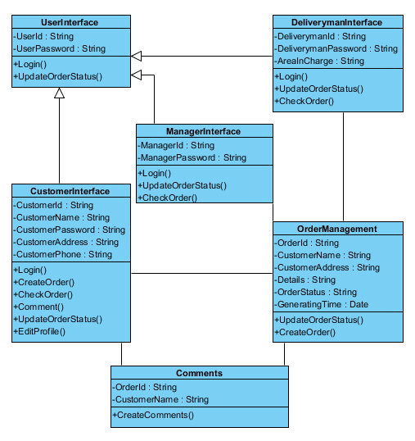

UI

